**Acknowledgement**

We are glad to receive support from our teachers, and friend for completion of our project. We are so thankful for their help and support. We want to express my appreciation to LBEF campus for giving me such a huge opportunity. And also, I would like to thank APU (Asia Pacific University) for providing this opportunity and providing materials for it.

I would also like to thank my project supervisor Prof (Dr.) Sandeep Kautish for helping me solving all the problems that came in between. With his knowledge I am able to complete this investigation report. Without his guideline the project might not have been completed.

Lastly, we will like to express our gratitude with our teachers and friends for understanding and providing support towards us to complete this assignment.

Sohil Byanjankar (NP000339)

B.Sc. (Hons)IT, 6th semester

**Abstract**

Sentiment analysis is the automatic process of text analysis that detects emotions from the text. In digital word most of activities are performed digitally. HotelZz web application is a web-based system which makes users to find hotels in easy way. This web application system helps user to find good hotels according to user preference and there rating. This web application system makes user fast and easy to decide which hotel is good and bad. This sentiment analysis is used for hotels comment and generating rating of hotel from users’ feedbacks and users know the hotel which is good or bad services. This project main purpose is to find the best hotels for people and save the time.

From the project's background through its scope and goal, technical research, literature review, and conclusion, the investigation is divided into seven chapters. Random students were selected for the survey, which was conducted via online questionnaires. In today's environment, implementing the system will be extremely beneficial to all parties involved, including instructors, administrators, and students.

**(Keyword: Sentiment Analysis, Web application System, Hotel finder)**

**Background of the project**

The HotelZz the name of this web-application which is totally link on sentiment analysis that automatic process for text analysis. The word sentiment analysis is the process of text analysis and it detects the emotional and opinion tone that comes through in the writings, and is also used as an opinion mining tool. This app makes it simple for users to find a good or terrible hotel. HotelZz is a web-app system that assists users in finding hotels based on their preferred hotels. This Hotel finding app shows good or bad rating the hotels according to user’s comment. Thus, users It helps the user in resolving the issue of finding a suitable hotel. This sentiment analysis helps in the analysis of user-provided feedback and hotel comment reviews. We categorize these sentiment analyses in our system into positive, negative, and neutral states, and these three categories automatically provide a rating to the hotel. This HotelZz Web application allows customers or users to search for hotels without having to go to different locations. This application assigns ratings to hotels so that users can easily find the best hotels.

There are many hotels in Nepal, but most people have no idea which ones are good or terrible. Many people do not like to travel to hotels that they don’t know which hotels provide greater services. So, the HotelZz web app helps users by giving hotel details as well as ratings for these hotels. This makes easier to people's for choosing hotels and also saving their valuable time. The HotelZz web application is the ideal answer for those who are too busy to select a suitable hotel.

**Problem Statement**

Online services are used by the vast majority of people nowadays. They engage in a number of different online activities. People buy plane tickets, hotel rooms, and restaurants as well as payment with their phones. In the same way, hotels are quickly growing, and many visitors are unsure how to choose the perfect hotel. The main issue is that they are unable to find the best possible hotels that provide excellent services in accordance with their requirements. It also wastes people's time because they have to go from one location to another in order to find high class and best services. People who want to travel on a holiday trip with their family and friends are mainly suffered by this such types of problem. They are just searching the hotels randomly and picked one by looking the outside of the hotel decoration, at this time they are unaware of this hotel facilities as well as its services. Users are having difficulty finding the best hotel. People have had headaches and other issues as a result of choosing a hotel from a large number. It's difficult to manually choose the perfect hotel for their needs. As a result, our hotel finder application system assists users in discovering every information of a hotel as well as all services and opportunities.

**Rationale**

As a result of the issues mentioned, this sentiment analysis is artificial intelligent. HotelZz is the name I gave to this web application. Sentiment analysis is an automated text analysis process that detects emotions from a text. It detects the emotional and opinion tone which carriers from writings and it is also used as an opinion mining tool. This application makes simple for users to find a good or bad hotel. HotelZz is a web-app system that assists users to find hotels based on their preferred hotels. This hotel finding app assigns a positive or negative rating to each hotel according to user’s comment. Thus, it helps user to solve the problem in difficult to choose a good hotel.

**Potential benefits:**

**Tangible Benefits:**

* People who have used this app they can save the time. It makes people happier for finding the good and bad hotels by giving reviews. (Duan, 2013)
* People can select the hotels as per their sentiment which will help them to find the suitable location through the help of AI.
* Users can compare several hotels and choose the best one among the recommendation made by the system.

**Intangible Benefits:**

* Due to the details of the hotels provided by the system users should not waste their time looking for the information about the hotel and save their time,
* Much convenient for the people who are using the application since there will be good hotels as per the reviews of the previous visitors of the hotels.

**Target Users**

The major purpose for developing this application is to save people's time and providing them the best hotels that they want. By focusing on those people who regularly travel from one location to another, such as travelers and tourists. Those who are mostly interested in traveling. This application provides the targeted users to best and cheapest hotels.

**Scope and Objectives**

**Aims**

The aim of research is to find the good hotels for users and helps the users to separate a good or bad hotel. It also makes user choice easy and saves time.

**Objectives**

* To integrate Sentimental Analysis to make rating from the feedbacks.
* To develop the hotel finder app by using this sentiment analysis.
* To develop as well as design of frontend as well as backend of the web-app system.
* To save the user’s valuable time.
* To suggest best hotels as well as details of the hotels to the users.

**Deliverables**

We're working on a system that will assist users in finding good hotels. Our hotel finding web application system helps users to choosing higher-quality hotels and displays all hotels with a single click of the app. This our system is easy to use for people and helps in save the time for people. In this hotel finder web app system, it has admin to control of the system. Whereas the administrator has power to manage the hotels details as well as the users of the system. This hotel finder web application system helps to provides easy and quick results for people with this search-box features. Sentiment-Analysis is the main feature that we used in our web application system. This sentiment analysis is used for generating rating of hotels according to the feedbacks provided by the users. In this web application system, by using sentiment-analysis it automatically generates the rating for hotels and shows the users to identify which is good/bad hotel. Users can login to the system. Those users who are registered in our system they can comment or give reviews to a particular hotel whereas those users who are not registered in our system they are able to view and search the hotel but cannot give reviews to a hotel which would be the limitation for un-registered users.

The following are the HotelZz application will be implemented in the system

* **Admin**
* can modify hotel
* can manage users
* can manage comments
* **User**
* can view hotels
* can view hotel details
* can register
* can login
* can search hotels
* can add favorites hotels
* can view favorites hotels
* can remove favorites
* can give feedbacks
* can sign out
* **New Features**
* Sentiment-Analysis is the main feature that we used in our web application system.
* This sentiment analysis is used for generating rating of hotels according to the feedbacks provided by the users.
* Users who are registered in our system they can comment or give reviews to a particular hotel whereas those users who are not registered in our system they are able to view and search the hotel but cannot give reviews to a hotel.
* Registered users are able to bookmark their favorite hotel whereas unregistered users are not able to book mark those hotels which they like.
* Provides easy and quick results for people with search-box features.

### Nature of Challenges

First of all, and importantly, I must complete the user browsing experience. The systems compatibility with many browsers is a difficult undertaking. Various users have different perspectives and prefer different sorts of browsers for system operation, such as Google Chrome or Firefox. Similarly, with the right procedures, the websites security becomes more difficult. The following issues, data architecture and API integration, are more time consuming and need more effort. In addition, the backend may be more complex. The reviews given by the users may not be accurate due to which the reputation and rating of the hotels can be affected and hamper their business. Training large dataset containing uncertain data of hotels reviews results having of low accuracy of the model.

## Overview of this Investigation report

Chapter 1: The project's background, the need to construct the application in the current setting, the obstacles and benefits of implementing the application in a real-life scenario are all discussed in Chapter 1 of the inquiry report. The chapter also includes a study of users as well as an introduction to the project application itself.

Chapter 2: In chapter 2, the literatures and research materials used to study and build the project are evaluated, including online sources, existing applications, journals, research papers, books, theories, and ideas. The literature and research review are crucial in determining the direction for app creation, implementation, and learning guidance.

Chapter 3: The study of technical resources such as programming languages, methodologies, libraries, development environments, and data storage implementations is covered in this chapter 3. In addition, the chapter discusses why technology is being implemented in the current situation, as well as how to change procedures for better results.

Chapter 4: The execution of the system's specialized development methodology, as well as a comparison of the approach to other existing development practices, are covered in this chapter.

Chapter 5: In this Chapter 5 describes the research methodology and instruments utilized in system development and deployment. It covers topics including building the application in accordance with studies and recommendations obtained from past research.

Chapter 6: In Chapter 6, the discussion and validation of acquired data, as well as the segmentation of questionnaires questioned for accomplishing the goals and reasons for the current system development, are discussed.

Chapter 7: The previous chapters, studies, and data acquired throughout the entire investigative report are summarized and concluded in this section.

## Project Plan

|  |  |  |  |  |
| --- | --- | --- | --- | --- |
| Task ID | Task | Start Date | End Date | Duration |
| WBS-C-1 | **Chapter 1: Introduction** | 9/17/2021 | 9/30/2021 | **10** |
| WBS-C-1-1 | Background of the project | 9/17/2021 | 9/18/2021 | **1** |
| WBS-C-1-2 | Problem Context | 9/19/2021 | 9/20/2021 | **1** |
| WBS-C-1-3 | Rationale | 9/21/2021 | 9/23/2021 | **2** |
| WBS-C-1-4 | Potential Benefits | 9/24/2021 | 9/25/2021 | **1** |
| WBS-C-1-5 | Targeted Users | 9/25/2021 | 9/26/2021 | **1** |
| WBS-C-1-6 | Scope and objectives | 9/26/2021 | 9/27/2021 | **1** |
| WBS-C-1-7 | Deliverables of the project | 9/27/2021 | 9/28/2021 | **1** |
| WBS-C-1-8 | Overview of Investigation report | 9/28/2021 | 9/29/2021 | **1** |
| WBS-C-1-9 | Project plan | 9/29/2021 | 9/30/2021 | **1** |
| WBS-C-2 | **Chapter 2: Literature Review** | 9/30/2021 | 10/20/2021 | **15** |
| WBS-C-2-1 | Introduction | 9/30/2021 | 10/1/2021 | **2** |
| WBS-C-2-2 | Domain Research | 10/2/2021 | 10/9/2021 | **6** |
| WBS-C-2-3 | Similar System Research | 10/10/2021 | 10/16/2021 | **5** |
| WBS-C-2-4 | Summary | 10/17/2021 | 10/20/2021 | **2** |
| WBS-C-3 | **Chapter 3: Technical Research** | 10/14/2021 | 10/26/2021 | **9** |
| WBS-C-3-1 | Programming language | 10/14/2021 | 10/18/2021 | **3** |
| WBS-C-3-2 | DBMS | 10/18/2021 | 10/20/2021 | **2** |
| WBS-C-3-3 | IDE | 10/20/2021 | 10/23/2021 | **2** |
| WBS-C-3-4 | Operating System | 10/23/2021 | 10/26/2021 | **2** |
| WBS-C-4 | **Chapter 4: System Development** | 10/26/2021 | 11/5/2021 | **9** |
| WBS-C-4-1 | Introduction | 10/26/2021 | 10/28/2021 | **2** |
| WBS-C-4-2 | Investigation of methodologies | 10/28/2021 | 11/2/2021 | **5** |
| WBS-C-4-3 | Selection Justification | 11/2/2021 | 11/5/2021 | **2** |
| WBS-C-5 | **Chapter 4: Research Methods** | 11/5/2021 | 11/11/2021 | **5** |
| WBS-C-5-1 | Introduction | 11/5/2021 | 11/9/2021 | **4** |
| WBS-C-5-2 | Design | 11/9/2021 | 11/11/2021 | **1** |
| WBS-C-6 | **Chapter 5: Requirement Validation** | 11/11/2021 | 11/21/2021 | **8** |
| WBS-C-6-1 | Analysis of collected data | 11/11/2021 | 11/16/2021 | **4** |
| WBS-C-6-2 | Introduction | 11/16/2021 | 11/18/2021 | **2** |
| WBS-C-6-3 | Questionnaire analysis | 11/18/2021 | 11/21/2021 | **2** |
| WBS-C-7 | **Conclusion and Reflections** | 11/21/2021 | 11/25/2021 | **5** |
| WBS-C-7-1 | References | 11/21/2021 | 11/23/2021 | **2** |
| WBS-C-7-2 | Appendices | 11/23/2021 | 11/25/2021 | **3** |

# Chapter 2: LITERATURE REVIEW

## Introduction

A literature review is a search and evaluation of the existing literature in the selected topic area or subject. It provides the most up-to-date information about the subject or topic you're writing about. It compiles a summary of the information found in the literature. It gives a broad perspective of the system, which aids comprehension. It includes key literature that provides a thorough understanding of the project's progress.

For the literature review portion, I will perform a thorough assessment of various types of articles, research work, and books related to my project topic. I will be able to get a certain amount of knowledge from this research, which will be useful during the development of the proposed system. Not only that, but by conducting a literature review, I will obtain fresh knowledge from any other prior similar projects or systems, which will help me broaden my expertise on the chosen issue. Furthermore, this will really help me in the understanding of web applications and their uses in the creation of hotel finder with sentiment analysis.

## Domain research

1. According to (Bedi & G, 2019), the accuracy of these three-text algorithm classification. This project is totally depending on text classification. In this project the author has compare these two classifiers one is Naïve Bayes and another is Support Vector Machine. The Naïve-Bayes classifiers Scored 83.1% accuracy whereas Support Vector Machines scored 54.6% accuracy. Thus, in text classification it shows Support Vector Machines has high accuracy than Naïve-Bayes.
2. According to (Malik & U, 2020),the project performed generating the movie reviews which is automatically generating from users reviews for the extraction of sentiment. CNN (Convolutional Neural Network), LSTM and SNN are classifiers which is a part of RNN. Using this SNN classifier it scored 75.68% accuracy for testing whereas it scored 84.52% accuracy for training. Likewise, using this CNN classifier scored 92% accuracy of training whereas it scored 82% accuracy of testing. Therefore, Convolutional Neural Network is better than SNN. At the end, LSTM is used to test and train of dataset. LSTM scored 85.04% accuracy for testing dataset whereas 85.40% accuracy for training dataset. Thus, LSTM is better than CNN and SNN.
3. According to (Geetha, et al., 2017),they establish a relationship between online reviews and customer rating for different hotels. This project is depending on customer sentiment. It is customers emotion which is expressed by text reviews. This can be positive as well as negative or neural. They compare with, managers of hotels and premium hotels which would provide good hotel services as well as staff performance. This study is not factoring like users review distance. Sentiment can be analyzed for customer ratings and reviews of the hotels.
4. According to (Aloqaily, et al., 2020), in this project sentiment analysis mainly two approaches are applied which are machine-learning and lexicon-based approach. These approaches are evaluated on an Arabic tweet’s dataset about the war. There are mainly 5 popular machines learning which is evaluated as well as applied. According to result, the LMT algorithm collected the highest results. The simple logistic and the SVM algorithms collected low result. Therefore, the result is shown in performance evaluation measures. LMT algorithms shows the best performance results which is Acc= 85.55, F1= 0.92 and AUC= 0.86.
5. According to ( (Manosso, 2021), The information age generates a lot of data in cyberspace, including product reviews from customers. Sentiment analysis can provide rough recommendations in the form of sentiment from a collection of reviews or can provide recommendations in more detail about sentiment in a particular aspect called aspect-based sentiment analysis (ABSA). The purpose of this research is to analyze the sentiment of restaurant reviews using the rule grammar method to extract implicit aspects - explicit opinions in four sentence models, namely simple (Si-AIOE), compound (Co-AIOE), complex (Ce-AIOE), and compound-complex (CoCe-AIOE). The results of the ABSA showed that the performance of proposed method achieve for precision, recall, and f1-measure were 0.84, 0.89, and 0.87, respectively.
6. According to (Medhat, Hassan, & Korashy, 2020),Sentimental analysis or Option mining is an ongoing field of text mining field. It is computation studies of people’s emotions, options and attitudes toward an entity. The entity can represent individuals, event or topics. This event or topics are covered by reviews. The classification algorithms of sentiment analysis are mainly three types. There are Naïve Bayes, Support Vector Machines and Neural networks. Some of people chooses using Naïve-Bayes than Support Vector Machines and Long short-term memory. Some of people chooses using Long short-term memory than Naïve Bayes and Support Vector Machines in their project.
7. According to (Santos D. , Cicero, Gatti, & Maira, 2019) ,this project is totally depends on short-text. The short-text is such as sentences which is in single line. The full form of NNA is Neural Network Algorithm, SSTb is Stanford Sentiment Treebank and SST is Stanford Twitter Sentiment. In this project NNA is used. They used SSTb and STS domains. Stanford Twitter Sentiment contains Twitter message and it scored 86.4% accuracy whereas Stanford Sentiment Treebank scored 85.7% accuracy from movie reviews.
8. According to (Santos & Cicero, 2018),In this paper Author A has described about a Deep Convolutional Neural Network (DNN) where he has performed two sentiment detection tasks which are message polarity classification and contextual polarity disambiguation. They have used their proposed approach for the SemEval2014 Task 9: Sentiment Analysis in Twitter where they got very competitive results for Twitter data.
9. According to ( (Thet, et al., 2020), sentiment analysis is automatic method of movie reviews and rating which they proposed as well as implemented and evaluated. It focuses on only sentiment orientation which is positive and negative. Sentences in reviews documents that express different sentiments analysis as well as different aspects of a movies. It prior sentiment scores 32000 individual words which are derived from SentiWordNet by the help of lexicon.
10. According to (Alhumoud, 2018), in this project there are 4 variables of data classifier. They are one is “True Positive”, two is “True Negative”, three is “False Positive” and four is “False Negative”. The data and information that are positively categorized by the classifier which is really positive is known as True-Positive. The number of data and information where classifier categorized the data and information as negative when the data/information is really negative is known as True-Negative. The number of data as well as information when classifier categorized as positive when the actual data and information is negative is known as False-Negative. The number of information where classifier categorized the data and information as negative when the data and information is really negative is known as True-Negative.
11. According to (Mouthami, 2018)in this project there are 4 variables of data classifier. They are one is “True Positive”, two is “True Negative”, three is “False Positive” and four is “False Negative”. The data and information that are positively categorized by the classifier which is really positive is known as True-Positive. The number of data and information where classifier categorized the data and information as negative when the data/information is really negative is known as True-Negative. The number of data as well as information when classifier categorized as positive when the actual data and information is negative is known as False-Negative. The number of information where classifier categorized the data and information as negative when the data and information is really negative is known as True-Negative.
12. According to (Levi, et al., 2019), this project is determining the opinion showed in the review on each feature, whether they are positive reviews or negative reviews. They need to allocate a corresponding sign to a feature’s weight. They use an opinion-lexicon to infer the opinion polarity. An option lexicon is a word phrases which shows and express positive reviews or negative reviews sentiments. The negation rule which words like no, not etc. take the opposite orientation shown by the opinion word and the other is the But-clause rules is a sentence that contains word like ’but’ also needs special action.
13. According to (Alhumoud, 2018), Consumer transactions and individual's online information exchange streams hold within them an enormous amount of data that is large in volume, velocity of generation, and variety. Extracting information and trends from these data is a valuable asset in getting a better understanding of consumer's activities and preferences to guide future decision-making. Consequently, analyzing customer reviews through sentiment analysis classification is increasingly growing in interest. However, the resources and lexicons available to aid the classification learning are still scarce. The present research presents a domain-specific lexicon, enhancing the analysis intelligence of customer reviews on services. The Lexicon for Sentiment Analysis for Reviews (LSAR) is applied using semi-supervised SVM classification. Results were encouraging, showing that the classifier based on the proposed lexicon, LSAR achieved better accuracy 0.94 compared to 0.72 for the AFINN-based classifier.
14. According to (Aloqaily, et al., 2020), With the rapid advances in the Web technologies, people have changed their way to obtain others’ opinion via the online review websites. Due to increase in user generated content on these mediums an important source for sentiment analysis is provided. For more detailed analysis, aspect-based sentiment analysis is getting increasingly important. And to complete this analysis implicit aspect extraction should be carried out. In this paper we suggested a graph-based Laplace smoothing method for extracting implicit aspects from hotel reviews in Turkish. The proposed method is evaluated according to F-measure. Experimental results show that proposed method is robust and efficient in extracting implicit aspects. with this property, domain and language independent implicit aspect extraction model is achieved for Turkish. Explicit aspect and sentiment word pair which provides highest relation accepted as a valid mapping. And consequently, from 175 non-explicit review sentences 45 different implicit aspects are extracted with 0.77 F-measure score.
15. According to (Mehta, 2020) , In this paper, its main focus on the basics of sentiment /opinion mining and its levels. There are various approaches and methods to identify sentiment from content. In this paper, our examination represents machine learning procedures. From various classification methods, Sentiment Analysis indicates the results into positive, negative and neutral scores. The study shows that machine learning methods, such as SVM, Naive Bayes, and neural networks have the highest accuracy and can be considered as the baseline learning methods as well as in some cases lexicon-based methods are very effective. In future work, discovering the result of various other combinations of text data and other on prediction accuracy can be done. More work in the future is needed to improve performance measures.
16. According to (Lal, 2019),In this paper, Opinion Mining has variety of uses. By analysis of online customer reviews the hotels can improve their services. It also helps customers to compare various hotels with the help of online reviews. Here this research paper have discussed various technologies of opinion mining. Papers referred have generated the polarity of reviews as positive, negative or neutral. Accuracy can be improved by selecting a suitable combination of selection of feature, Senti WordNet dictionary and classification algorithm. This paper have also shown the accuracy of various mining techniques used to determine the polarity of reviews.
17. According to (Henriquez, 2021), In this article, a semantic model was proposed for the extraction of explicit and implicit aspects in the Spanish language as a subtask of opinion mining. The system validation tests were carried out by means of a series of experiments, taking as reference the corpus of task 5 referring to aspects-based OM (aspect-based sentiment analysis) of the 2016 edition of SemEval. In the experiments, it was found that the proposed system obtained an F1 value of 73.07 in the process of extracting aspects, obtaining better results than the systems participating in SemEval.
18. According to (Koto, 2017), In this study we have constructed InSet Lexicon that comprises of 3,609 positive and 6,609 negative words in Indonesian language. Each word was manually labeled based on its polarity and then enhanced by adding the stemming and synonym set. Our research contributions lay on two points. First, we constructed the sentiment exicon for Indonesian language which is more suitable for microblogs. Second, our approach shows that the result outperforms all of the existing baseline methods where the highest accuracy is 65.78%. For the future works, the enhancement of lexicon can be conducted by incorporating the translated English lexicon with the InSet.

## Similar System/s

We compare our system with many different system and similar system created by different people. These systems are built by one group or and company team with their resources as well as their valuable time.

**Booking.com**

Booking.com has grown from a small Dutch startup to one of the world’s leading digital travel companies. Part of Booking Holdings Inc. (NASDAQ: BKNG), Booking.com’s mission is to make it easier for everyone to experience the world. This web application facilitate hundreds of thousands of transactions every day through our secure platform, and work to the highest standards to guarantee our privacy. (Booking.com, 2021)

Booking.com is the web application that helps user to discover the great places to stay in the city. This booking.com web app also gives the details of the hotels like locations and review of the hotels. This application lets user to reserve or book hotel in online as user can view the hotels prices, pictures, location and its rating. This is a great hotel finder web-application. This web application has every hotel’s location. For example, Nepal’s hotels location/address is available in this web application.

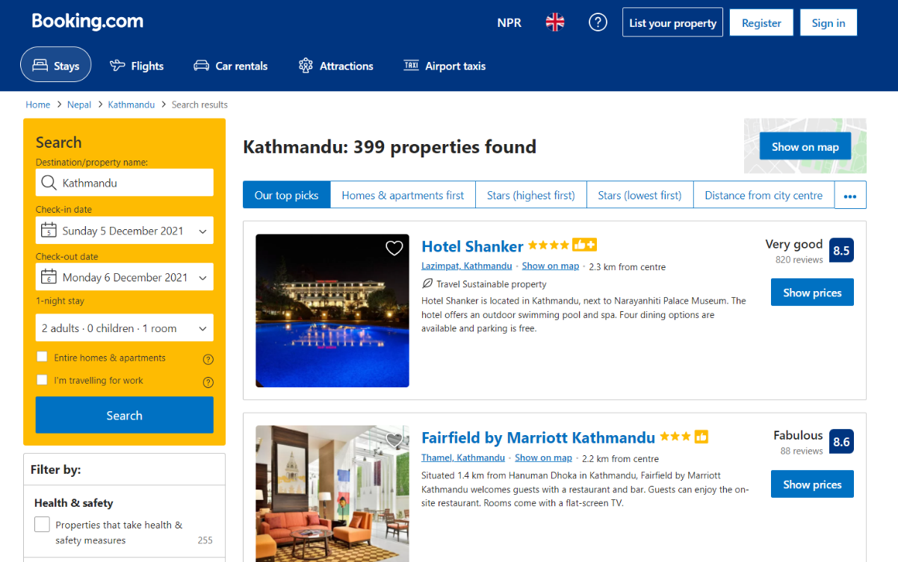

Figure 1 Bookinf.com

**Trivago**

Trivago is a hotel search engine that compares prices. The prices displayed are taken from a variety of hotel and booking websites. This implies that, while consumers can choose which hotel best meets their needs on trivago, the booking procedure is handled by the booking sites. We will be directed to a booking site where you can finalize the reservation for the hotel offer identified on trivago by clicking the "view deal" button.

We can simply select the desired hotel and compare costs from many websites with trivago. Simply input your desired destination and travel dates, and our hotel search engine will compare hotel prices for you. Simply select your search results by price, distance, star category, facilities, and more. Trivago makes booking hotels online simple, from inexpensive hostels to luxurious suites. We can choose from a wide range of rooms and places in the United States, such as San Francisco and Chicago, as well as major cities and vacation destinations throughout the world!

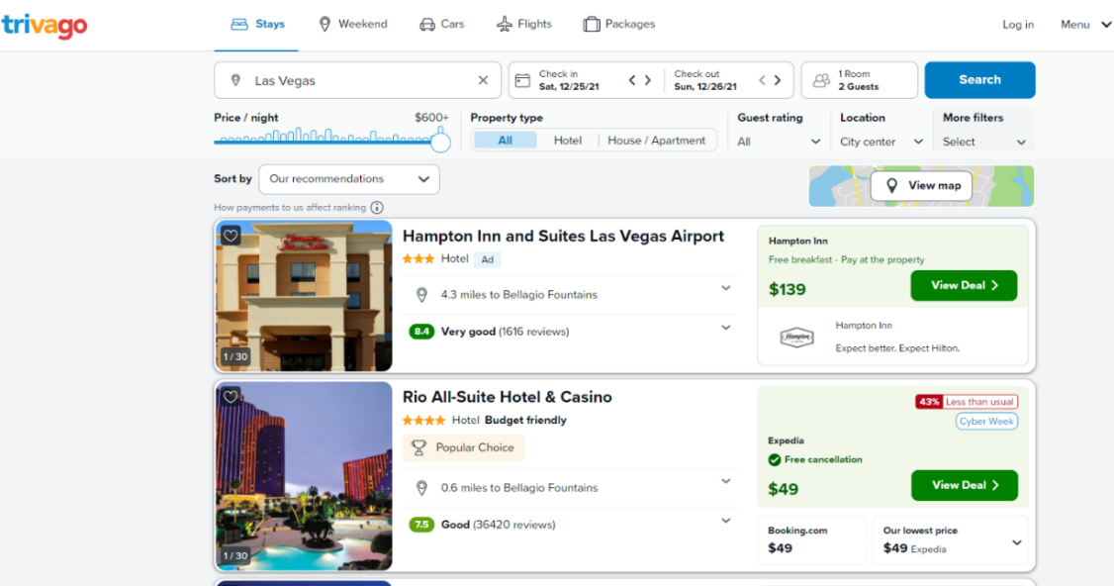

Figure 2 Trivago

This system gives the details of the hotels like locations and review of the hotels, price of the hotels, shows the pictures of the hotels and book the hotels. This system also has search box.

## Summary

Here we can see the introduction of the proposed system hotel finder with sentiment analysis. Implementation strategies, ultimate product accuracy, and productivity will be the differences in creating through distinct modules. Here, from the research we can see the different system use of Navie Bayes Classifiers than other. From various classification methods, Sentiment Analysis indicates the results into positive, negative and neutral scores. The study shows that machine learning methods, such as SVM, Naive Bayes, and neural networks have the highest accuracy and can be considered as the baseline learning methods as well as in some cases lexicon-based methods are very effective. Here, we also compare similar web app.

# CHAPTER 3: TECHNICAL RESEARCH

## Programming language chosen (Provide at least two (2) for comparison purpose)

**Python**

I choose python language for this project. Python is a highly interpreted general-purpose programming language. Its design philosophy emphasizes code readability through the use of large indentations. The language constructs as well as its object-oriented approach aim to help programmers write clear and logical code for small- and large-scale projects.

**Java**

Java is a high-level, class-based, object-oriented programming language that is designed to have as few implementation dependencies as possible. Python is more popular than Java. Java is a statically typed and compiled language, and Python is a dynamically typed and interpreted language. This difference alone makes Java faster and easier to debug, but Python is easier to use and read. Python has grown in popularity, largely due to its ability to communicate; people grasp it more easily. With it, the libraries for Python are huge, so a new programmer won't have to start from scratch. Java is old and still widely used, so it also has a lot of libraries and a supportive community.

**Php**

PHP and Python are popular high-level programming languages ​​that have extensive open-source experience and provide extensive design documentation. The main difference between PHP and Python is that PHP is widely used for web development while Python is a versatile full-stack programming language. PHP is a server-side scripting language while Python is an object-oriented scripting language.

|  |  |  |  |
| --- | --- | --- | --- |
| **Comparison Factors** | **Python** | **Java** | **Php** |
| Speed | Faster than Php | Faster than python and php | Not much faster |
| Legacy | Yes | No | No |
| Code | Yes | No | NO |
| Practical Agility | Yes | Yes | No |
| Trends | Very popular | No | No |
| Salary | High | Low | Low |
| Cost | Free | Free | Free |
| Syntax | Yes | Yes | Yes |
| Specialized for | AI, Deep learning, Data analysis, web app, Games | build large enterprise class applications | web development and can be embedded into HTML. |
| Security | Very Secured | Not secured | Not secured |
| Backend | Django | Spring | Laravel |

## IDE (Interactive Development Environment) chosen

A software application that gives full tools to computer programmers for software development is known as an integrated development environment (IDE). A source code editor, build automation tools, and a debugger are all standard components of an IDE. I choose PyCharm for the development of the proposed system which is hotel finder using sentiment analysis (AI).

**PyCharm**

PyCharm is a Python IDE that includes a complete set of Python programming tools. The IDE also includes features for professional Web development with the Django framework. In a clever and customizable editor with code completion, snippets, code folding, and split windows support, users can code faster and more effortlessly.

For this project, IDE could be PyCharm where developers can write the code. PyCharm offers smart code completion, code inspections, on-the-fly error flagging and quick fixes, as well as automated code refactorings and rich navigation.

## Database Management System chosen (Provide at least two (2) for comparison purpose)

**SQLite**

For the development of this project, I choose SQLite database. SQLite is a C library that contains a relational database management system. SQLite is not a client–server database engine, unlike many other database management systems. Rather, it is incorporated into the final product. The syntax of SQLite is similar to that of PostgreSQL. SQLite is an Embedded DBMS. This means that it is a Serverless DBMS with the ability to run within the applications.

For most low-to-medium-traffic websites, SQLite works well as a database engine. The quantity of online traffic that SQLite can handle is determined by the website's database usage. SQLite should work perfectly for any site that receives fewer than 100K hits per day.

**PostgreSQL**

PostgreSQL is a powerful, open-source object-relational database system that has a solid reputation for stability, feature robustness, and performance after more than 30 years of active development.

SQLite is extremely quick due to its minimalist architecture and straightforward operations. If we only need rapid read operations, PostgreSQL can be overkill and appear less performant. PostgreSQL is a beast when it comes to complex operations.

|  |  |  |
| --- | --- | --- |
| **Comparison Factors** | **PostgreSQL** | **SQLite** |
| Description | Relational DBMS | Relational DBMS |
| Supported Programming Language | .Net, C, c++, Java, JS, PHP, python | Actionscript, ada, basic, c,c#, java, js, pthon,scheme,R |
| License | Open Source | Open Source |
| Server OS | UX, Linux, OS X, Windows, Solaris | Serverless |
| Editions | Community with option of commercial support | Community with option of pro support |
| Popular use case | Analytics, data mining, | Low-medium traffic wrbsite, testing and development |

## Operating System chosen

The operating system for this project. I have chosen Windows 10 pro for development of the project. This OS offers sophisticated connectivity and privacy tools such as Domain Join, Group Policy Management, Bit locker, Enterprise Mode Internet Explorer (EMIE), Assigned Access 8.1, Remote Desktop, Client Hyper-V, and Direct Access. Among the various version of windows. This Windows 10 pro is much faster and easier to use than other Operating System like Linux and windows 10 below.

## Summary

For this hotel finder with sentiment analysis web application, I choose python programming language likewise, I choose PyCharm IDE for development of the project and at last SQLite Database and windows 10 pro was chosen for development of this project.

# Chapter 4: System Development Methodology

The software development life cycle (SDLC) is a set of processes that help people comprehend the software development process. A software development methodology is a framework for planning, controlling, and structuring a project's overall development. There are several SDLC models, each with its own set of strengths and weaknesses, and the best one depends on the project at hand. The major goal of SDLC methodologies, on the other hand, is to create high-quality software that meets client expectations. The life cycle is a mechanism for enhancing software quality and the development process as a whole. A variety of methodologies can be employed to complete the job. Planning, analysis, design building, testing, deployment, and maintenance are the most typical developments in all SDLC approaches. This project uses iterative SDLC methodology to consider the complete development model. Waterfall, Agile, Spiral, Iterative, Incremental, and other methodologies are examples of system development methodologies. The Incremental model were chosen as the project's structural development approaches for the existing system.

Here is the comparison between two SDLC methodologies are follows:

|  |  |  |
| --- | --- | --- |
|  | **RAD** | **Incremental** |
| Development Type | Interactive | Sequential + Interactive |
| Most Appropriate for | Small Applications | Web Applications |
| Least Appropriate for | Real-time Applications | Interactive Applications |
| Strengths | Can be modified rapidly and close to implementation at every stage | Customers involved at all stages and quick to implement |
| Weakness | No firm deadlines and Difficult implementation issues delayed | Difficult implementation issued delayed |
| Risk Involvement | High | Medium |
| Cost | High | Medium |
| Risk | Project failure risk will be high | Project failure risk will be low |

## System development methodology chosen

From the above comparison table, the best method for this project seems to be Incremental method. To implantation of the sentiment analysis on the system.

## Incremental model

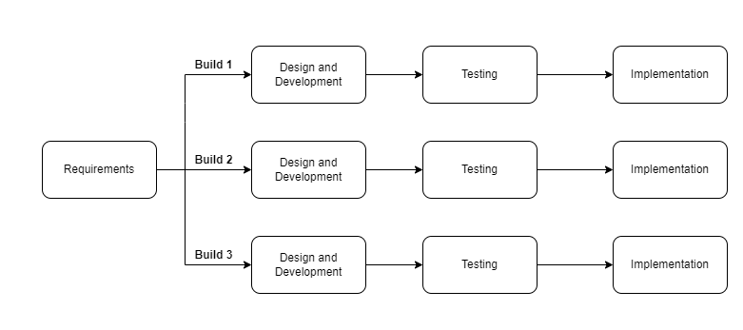

Figure 3 mechanism of Incremental model.

The incremental model is a software development process that divides requirements into numerous separate modules during the software development cycle. The incremental model iteratively brings together the parts of the waterfall model. It's a waterfall model that's been combined with another. It distributes a series of releases known as increments, each of which adds to the client's capability. Each module in this paradigm goes through the processes of requirements, design, implementation, and testing. Every release of the module after then adds functionality to the preceding iteration. The procedure is repeated until the entire system is completed. This method was chosen to process this system because it is more flexible and cost-effective to change scope and requirements, as well as being easier to test and debug during a smaller iteration. Risky elements are discovered and handled throughout iteration, which decreases the initial delivery cost and makes risk management easy.

**Build 1**

The project's web application, including the back end and front end, is constructed during the Build 1 phase. The majority of the coding is completed and tested here. When the front-end and back-end development is finished, the outcome is analyzed and tested. The project moves on to the following step, Build 2, after the design and development phase is completed.

**Build 2**

Data is managed and stored in the database during the incremental model's build 2 phase. The database stores the results of the user's review. In this process, hotels and user datasets are created and stored.

**Build 3**

Sentimental Analysis, which is part of the build 3 process, is used to implement Artificial Intelligence (AI). Natural Language Processing (NLP) and Long Short-Term Memory (LSTM) are used to accomplish this. The web application assesses the hotel based on user reviews after the AI has been implemented. Following completion, the result is examined and tested. If the tests come back positive, Now that the project is finished, it is ready to be delivered.

# CHAPTER 5: RESEARCH METHODS

## Introduction

The instruments that one utilizes to do research are referred to as research methods. These can be qualitative, quantitative, or a combination of both. Quantitative approaches investigate numerical data and frequently necessitate the use of statistical tools to analyze the information gathered. This permits variables to be measured and correlations between them to be developed. Graphs and tables can be used to depict this type of data. Non-numerical qualitative data focuses on establishing patterns. Mixed methods research combines qualitative and quantitative research approaches. Unexpected findings can be explained using mixed techniques.

**Data collection method used: Questionnaires though: Online surveys**

For the project I choose online questionnaire for collect the feedback of the system from peoples. This survey questionnaire is most important for this pandemic situation. A questionnaire is a research tool that consists of a series of questions designed to collect data from respondents. Questionnaires are similar to written interviews in that they collect information.

The research questionnaires are divided into distinct divisions based on general information, pre-conditions before to the coronavirus pandemic, its impacts, and the project's goals to tackle the problem. The surveys are being distributed to the general people in order to learn more about the situation before and during the current pandemic. It enquires into how individuals are maintaining their economic, health, and living standards in the existing environment, as well as how they are adjusting to changes brought on by application. The research questionnaires are divided into different groups based on the scenario and project requirements.

## Design

To allow for a more in-depth conversation with the general public and users, a series of questions was prepared. The questions were designed to gather data about user preferences, actions, thoughts, and other traits, all of which would be important in determining the profitability and success of the proposed initiative. A detailed analysis of the collected data can be used to determine whether the proposed project is worthwhile, and system enhancements can be made to satisfy the demands of the users.

A total of 20 questions, including two demographic questions were posted in the questionnaire, for both online and offline survey modes. There are 4 types of questionnaires in this survey form. First one is General Profiling, second one is Yes or No questions, third one is multiple choosing question and last one is descriptive question. Here, in this form all of them four types of questions were asked and all about the hotel finder with sentiment analysis web application.

Here are the General Profiling:

1. **What is your gender?**

Objective: To determine how many males and females were read this project.

1. **What is your status?**

Objective: To determine how many students were there in survey.

1. **What is your age?**

Objective: To determine how many young peoples was interested in this project.

1. **What is your Country?**

Objective: To determine the country of the respondents.

1. **Your current residence location?**

Objective: To determine the respondents current location.

1. **Your qualification?**

Objective: To determine the respondents qualification level.

Here are the Yes or No question for the system provided below:

|  |  |  |  |
| --- | --- | --- | --- |
|  | **Questions** | **YES** | **NO** |
|  | Do you want to visit hotel to know services/reviews of hotel? |  |  |
|  | Do you want to visit hotel to know services/reviews of hotel? |  |  |
|  | Do you want to know the hotels details by using this hotel finder app rather than visiting the hotel self? |  |  |
|  | Sentiment Analysis can to read your comment then give rating the hotels thus you don't need to give stars. Do you like this feature? |  |  |
|  | Will be the proposed system can help to find the best hotel? |  |  |
|  | Do you like to give the feedbacks on hotels comment sections? |  |  |
|  | This proposed system is fully based on Sentiment Analysis (emotion of your comment section) |  |  |

The third type of question is multiple-choosing question are:

1. **How often do you visit hotel?**
2. Occasionally b. Partially c. Sometime d. Never
3. **Do you prefer rating the hotel by giving stars or by comment sentiments?**
4. Star b. Comment Sentiment
5. **The suggested Hotel finder with sentiment analysis app is more effective than visiting the hotels.**
6. Strongly Agree b. Agree c. Disagree d. Strongly Disagree e. Neutral
7. **This proposed system can save the time for travelers without wasting time by visiting.**
8. Strongly Agree b. Agree c. Disagree d. Strongly Disagree e. Neutral
9. **Please rate this system.**

The fourth type of question is descriptive question are:

**1. Do you want to add extra features in this system? If yes then give your answers.**

**2. How will the proposed system will be beneficial for travelers?**

## Summary

Switching to questionnaires was a sensible approach to pursue for data gathering due to the current stage of the pandemic and the lack of availability of live interrogations. A great amount of data can be acquired due to its low cost and rapid effort. As a result, the measurement of project development can be worked on in order to establish a link between users and the population being monitored.

The current data collecting strategy for segmented questionnaires will be able to capture the semantics of the project objective and the essence of constructing the project to assist in adhering to health standards. The information gathered from respondents will be treated as a sample survey of the public, with a modest sample size used to multiply the functions and requirements for app development.

# CHAPTER 6: REQUIREMENTS VALIDATION

## Analysis of Data

For the development of this project, I made 20 questionnaires were sent out to the general public, and 50 of them were responded using Microsoft forms.

### Analysis of data collected through Questionnaire (if you have collected research data using this method)

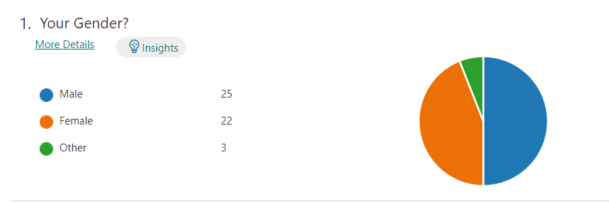

Figure 4 Survey Question 1

**Analysis:**

From the above pie-chart shows the gender of the people who were submit this survey form. In this above figure shows the respondents male, female and other category where 25 males, 22 females and 3 others will be submitting this form.

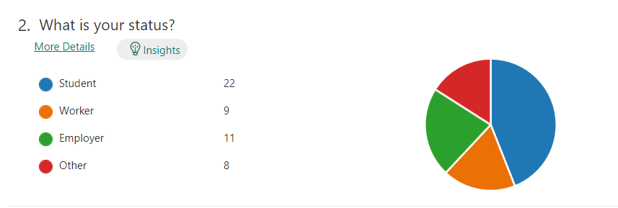

Figure 5 Survey Question 2

**Analysis:**

From the above pie-chart shows the status of the peoples who is student, worker, employer and other. In this survey form there are 22 students, 9 workers, 11 employer and 8 others were submit this form.

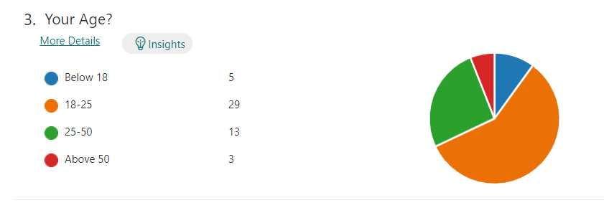

Figure 6 Survey Question 3

**Analysis:**

From the above pie-chart shows the age of the peoples. In this survey form it shows that 29 respondents were 18-25 and then 13 respondents were 25-50, 5 were below 18 and 3 respondents are above 50.

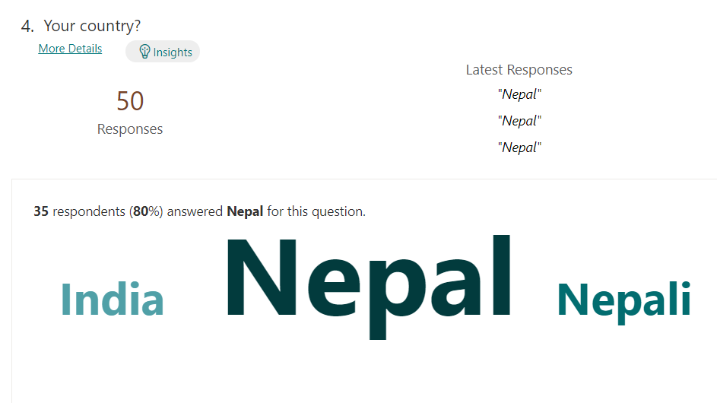

Figure 7 Survey Question 4

**Analysis:**

From the above figure shows that 80% of respondents were from Nepal country, where 20% of respondents were from other different country.

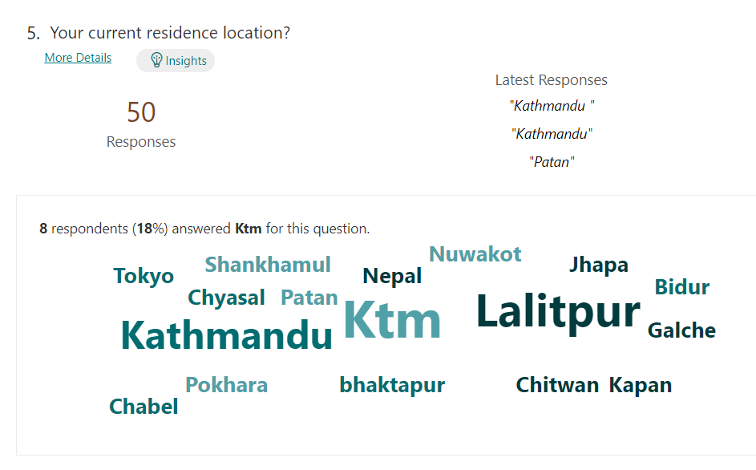

Figure 8 Survey Question 5

**Analysis:**

From the above figure shows that 18 % of respondents were from Kathmandu whereas the remaining 82% of respondents were from different locations like Lalitpur, Bhaktapur, Chitwan, Pokhara etc.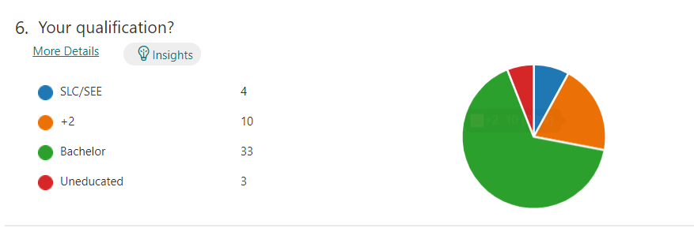

Figure 9 Survey Question 6

**Analysis:**

From the above figure shows the qualification level of respondents and that 33 respondents were in bachelor level which is highest than other levels. Here, 10 respondents were in +2, 4 were in SLC and 3 were uneducated.

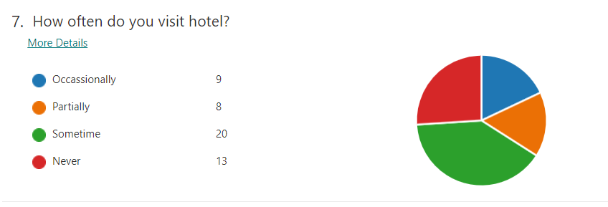

Figure 10 Survey Question 7

**Analysis:**

From the above figure shows that 20 respondents were visit the hotel sometimes. Whereas, the 9 respondents were in Occasionally visit hotel, 8 were partially visit hotel and 13 were never visit the hotel.

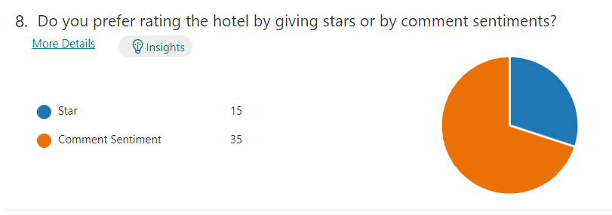

Figure 11 Survey Question 8

**Analysis:**

From the above figure shows that 35 respondents were prefer rating the hotel by comment sentiment and 15 respondents were prefer rating the hotel by stars.

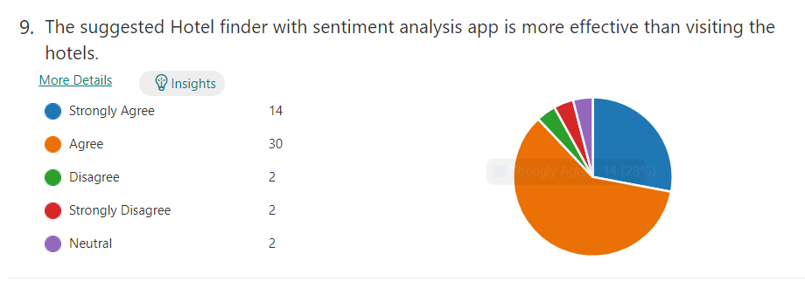

Figure 12 Survey Question 9

**Analysis:**

From the above figure shows the 30 respondents were Agree to App is more effective than visiting the hotels. Whereas, 14 were strongly agree, 2 were disagree, strongly disagree and neutral.

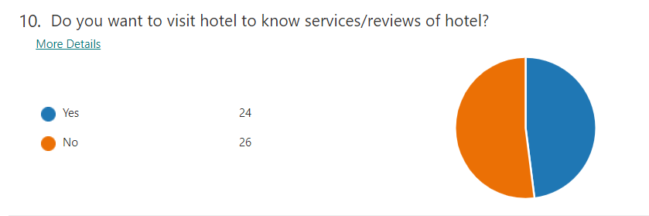

Figure 13 Survey Question 10

**Analysis:**

From the above figure shows the respondent peoples who visit hotels to know reviews of the hotels as well as services. Here, 26 respondents do not like to visit hotels to know services whereas 24 respondents like to visit hotels to know services.

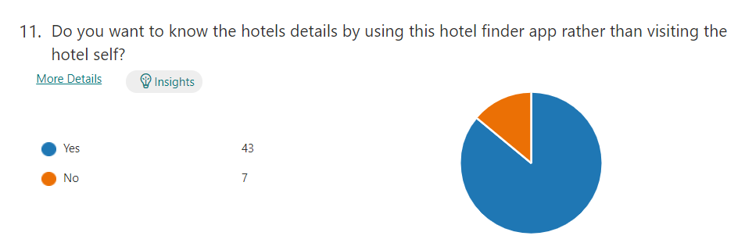

Figure 14 Survey Question 11

**Analysis:**

From the above figure shows that 43 respondents were select Yes for to know hotels details using App rather than visiting the hotels. Whereas, 7 respondents were select No.

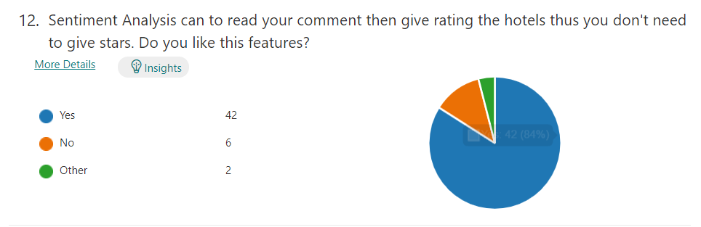

Figure 15 Survey Question 12

**Analysis:**

From the above figure shows that 42 respondents were like this sentiment analysis features. Whereas, 6 respondents don’t like this feature and 2 were in other.

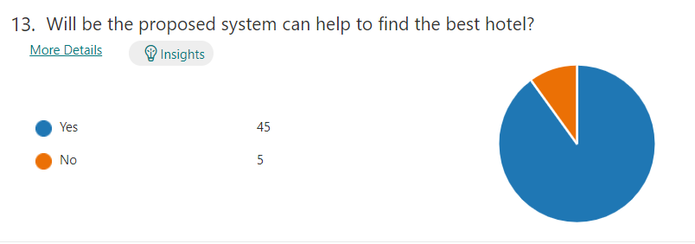

Figure 16 Survey Question 13

**Analysis:**

From the above figure shows that 45 respondents were know the proposed system can help to find best hotels. Whereas, 5 respondents didn’t think it will be help.

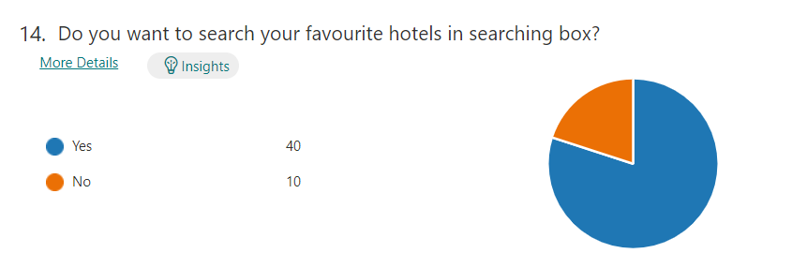

Figure 17 Survey Question 14

**Analysis:**

From the above figure shows that 40 respondents were want searching box to find the hotels. Whereas, 10 respondents don’t want search box.

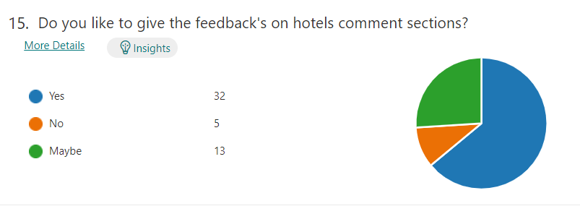

Figure 18 Survey Question 15

**Analysis:**

From the above figure shows that 32 respondents were likes the feedbacks on the hotel comment sections. Whereas, 13 were select maybe and 5 were select No. Here, 5 respondents didn’t like the feedbacks on the comment sections.

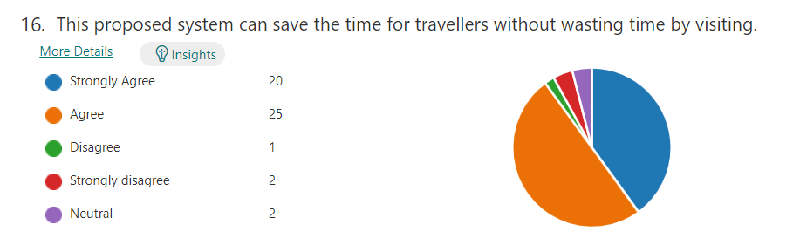

Figure 19 Survey Question 16

**Analysis:**

From the above figure shows that 20 respondents were strongly Agree for saving the time. Whereas, 25 respondents were Agree, 1 were disagree, 2 were Strongly disagree and 2 were neutral.

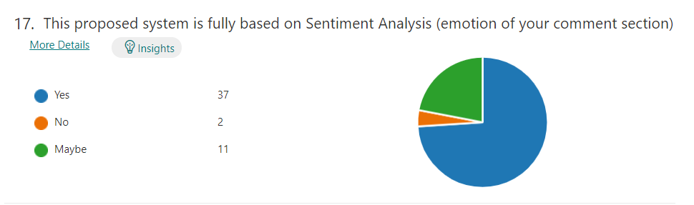

Figure 20 Survey Question 17

**Analysis:**

From the above figure shows that 37 respondents were select Yes for system based on sentiment analysis. Whereas, 2 respondents were select No and 11 were select Maybe.

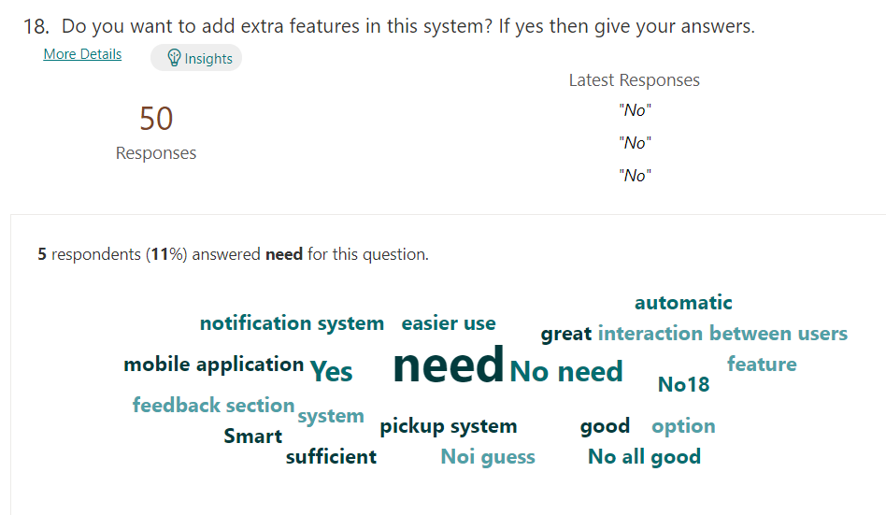

Figure 21 Survey Question 18

**Analysis:**

From the above figure shows that 11% of respondents were no need of new features in this system. Here, other notification system, mobile application features will be recommended by respondents.

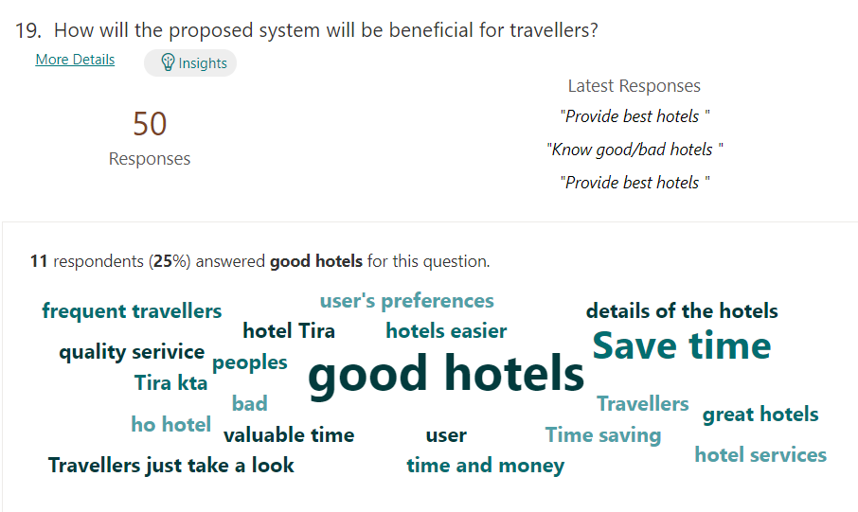

Figure 22 Survey Question 19

**Analysis:**

From the above figure shows that 25% respondents were answered good hotels which system gives for travelers. Whereas, most of the respondents were give the positive for this system.

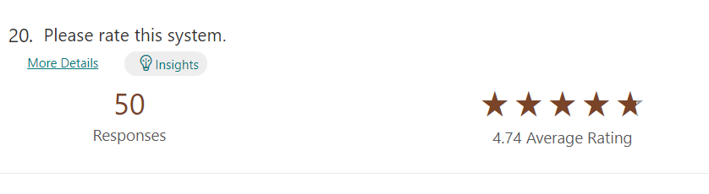

Figure 23 Survey Question 20

**Analysis:**

From the above figure shows that 50 respondents were rate this system. Here, rate will be in stars and we collected 4.74 average rating for this system.

## Summary

All of the 20 questions in the survey were asked to a random sample of the public in order to obtain data for inquiring the population in order to create the hotel finder with sentiment analysis. Most of the people believes that this hotel finder helps to solve the problem of being difficulties to find the hotels. As a result, our hotel finder with sentiment analysis web application is judged useful and acceptable by the general public.

# System Architecture

## Introduction

Sentiment Analysis

## Abstract Architecture

### System design

use-case diagram

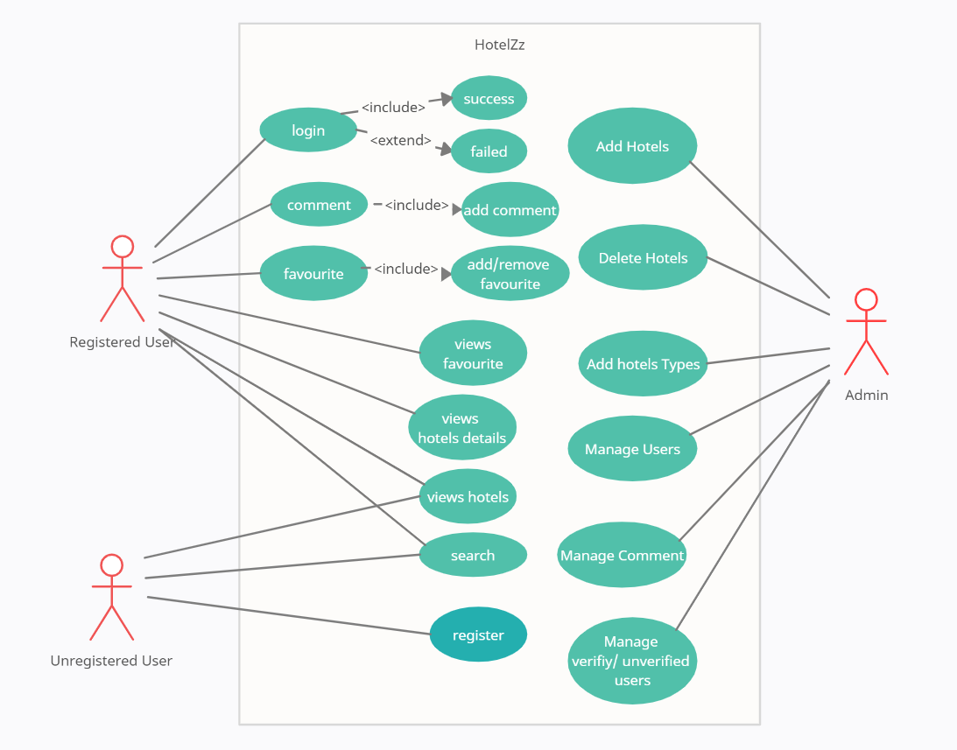

use-case specification

class-diagram

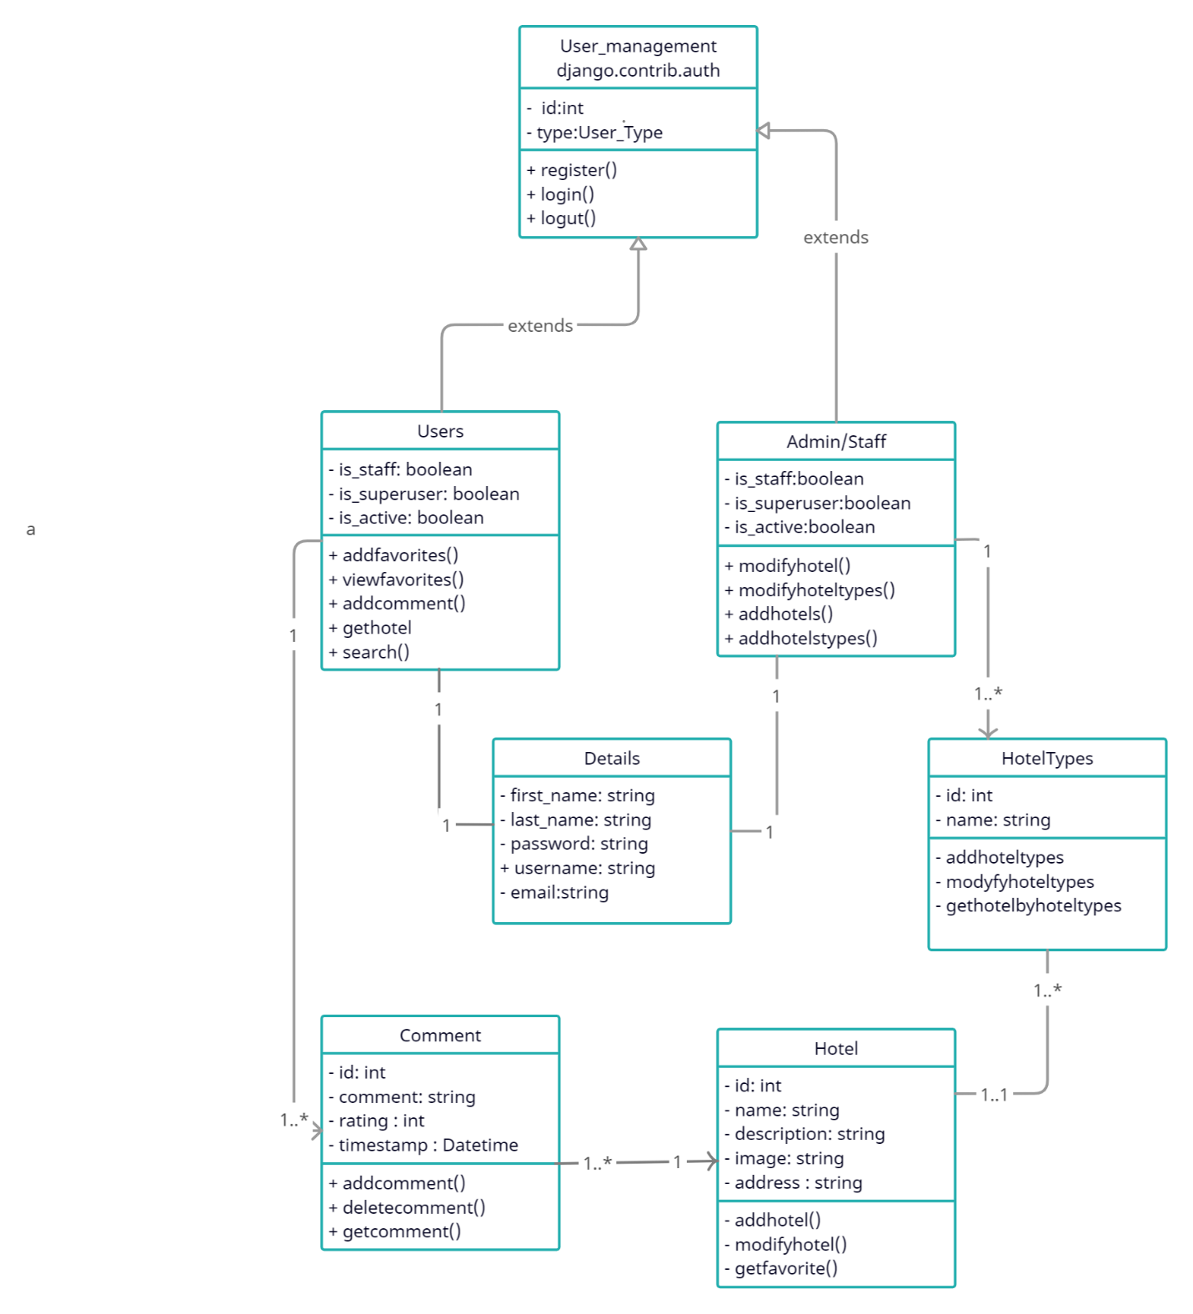

activity-diagram

sequence diagram

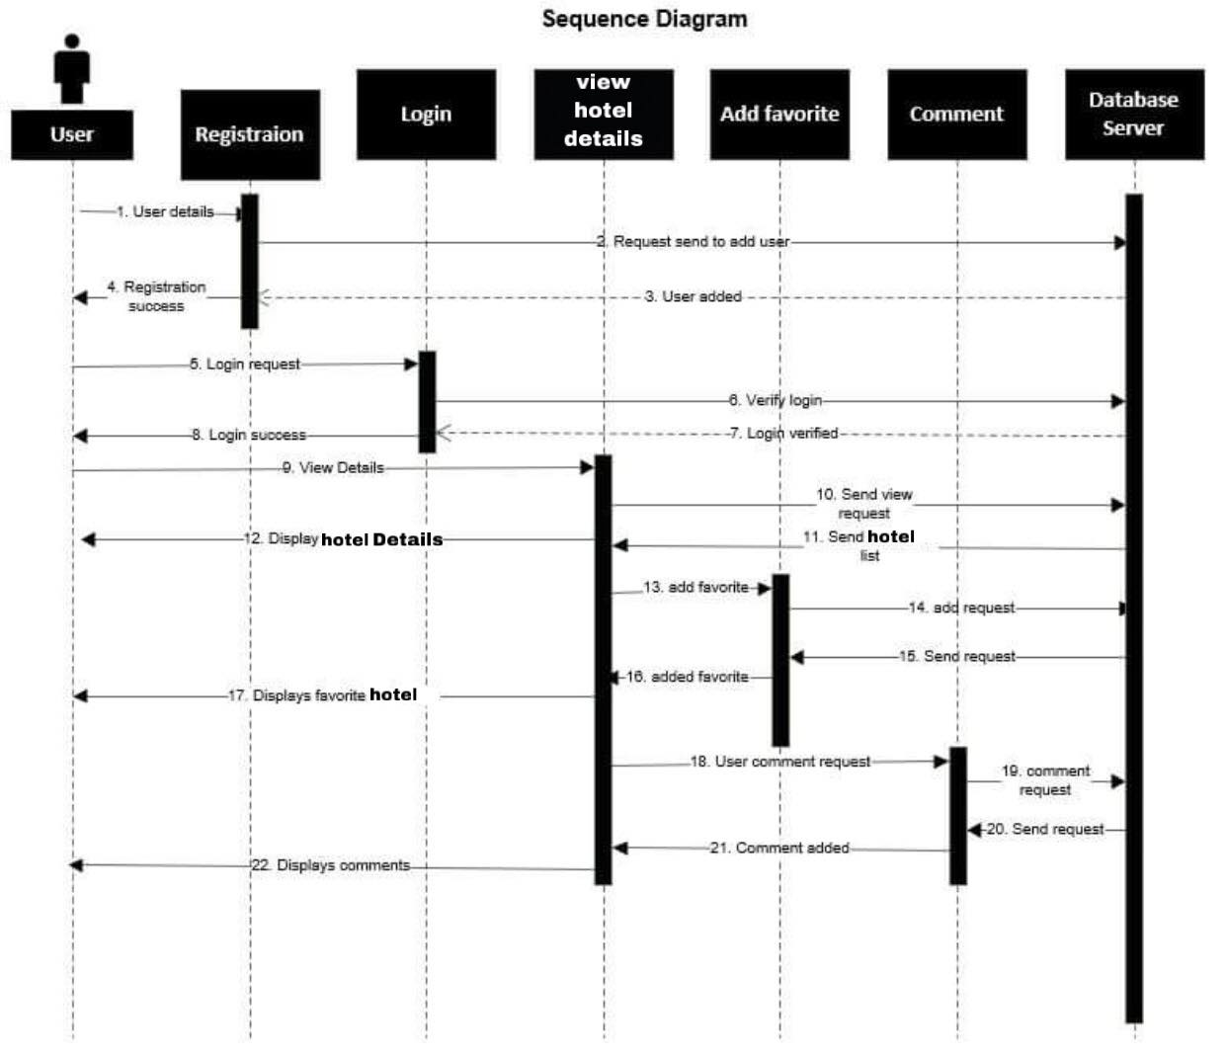

### Database design

#### Entity relationship diagram

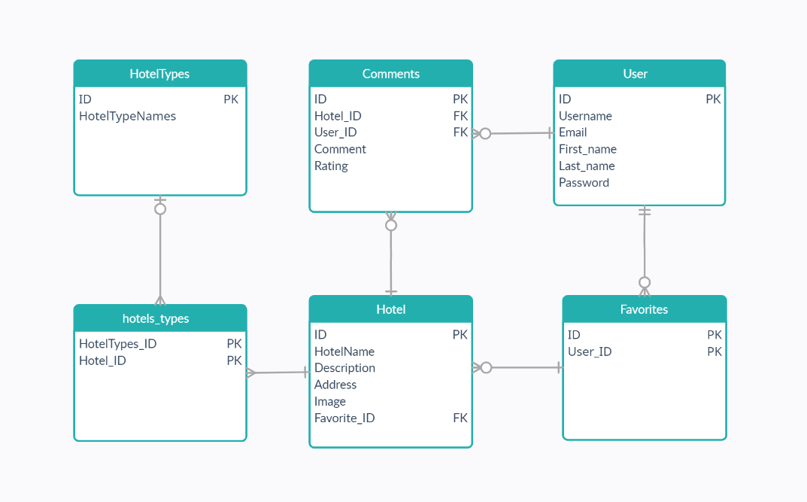

#### Database table structure

### Interface design

storyboard

# Project Plan

## Features

### Feature 1

**Sentiment Analysis:**

Sentiment Analysis integrated as AI. User can comment in hotels and AI will generate the rate of the hotels.

### Feature 2

**Favorite:**

User can add hotels to their favorites. User can see the shape of heart that user can add or remove the hotels from favorites.

### Feature 3

**Email Verification:**

When registration user can verify their email through their verification email.

# Implementation

## Screenshots

### Screenshot of home page

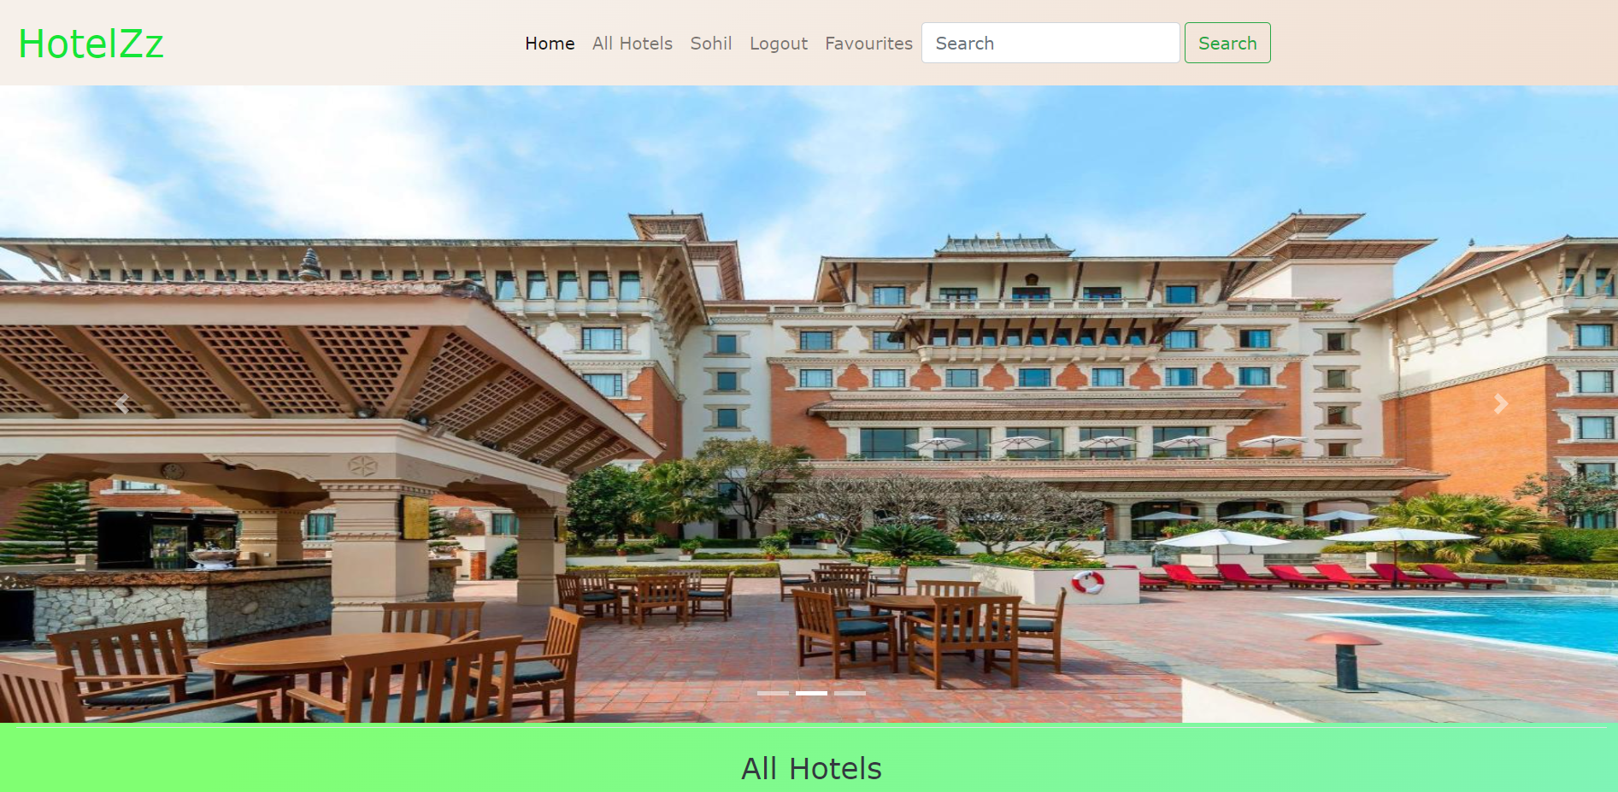

Figure 1 HotelZz Home Screen Page

#### Description

Here is the home page of the web application. It shows the HotelZz the name of the web application at top of the header and one search box. This search box can help the users to type their favorite in the search box. At the bottom of the picture shows the all of the hotels for the users. Here users can’t view details of the hotels without login.

#### Screenshot

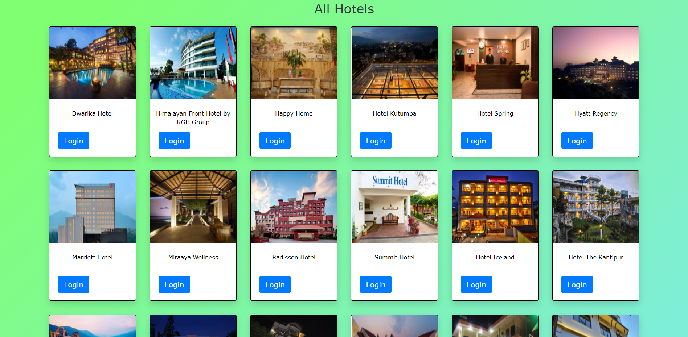

Figure 2 Hotels

### Screenshot of login page

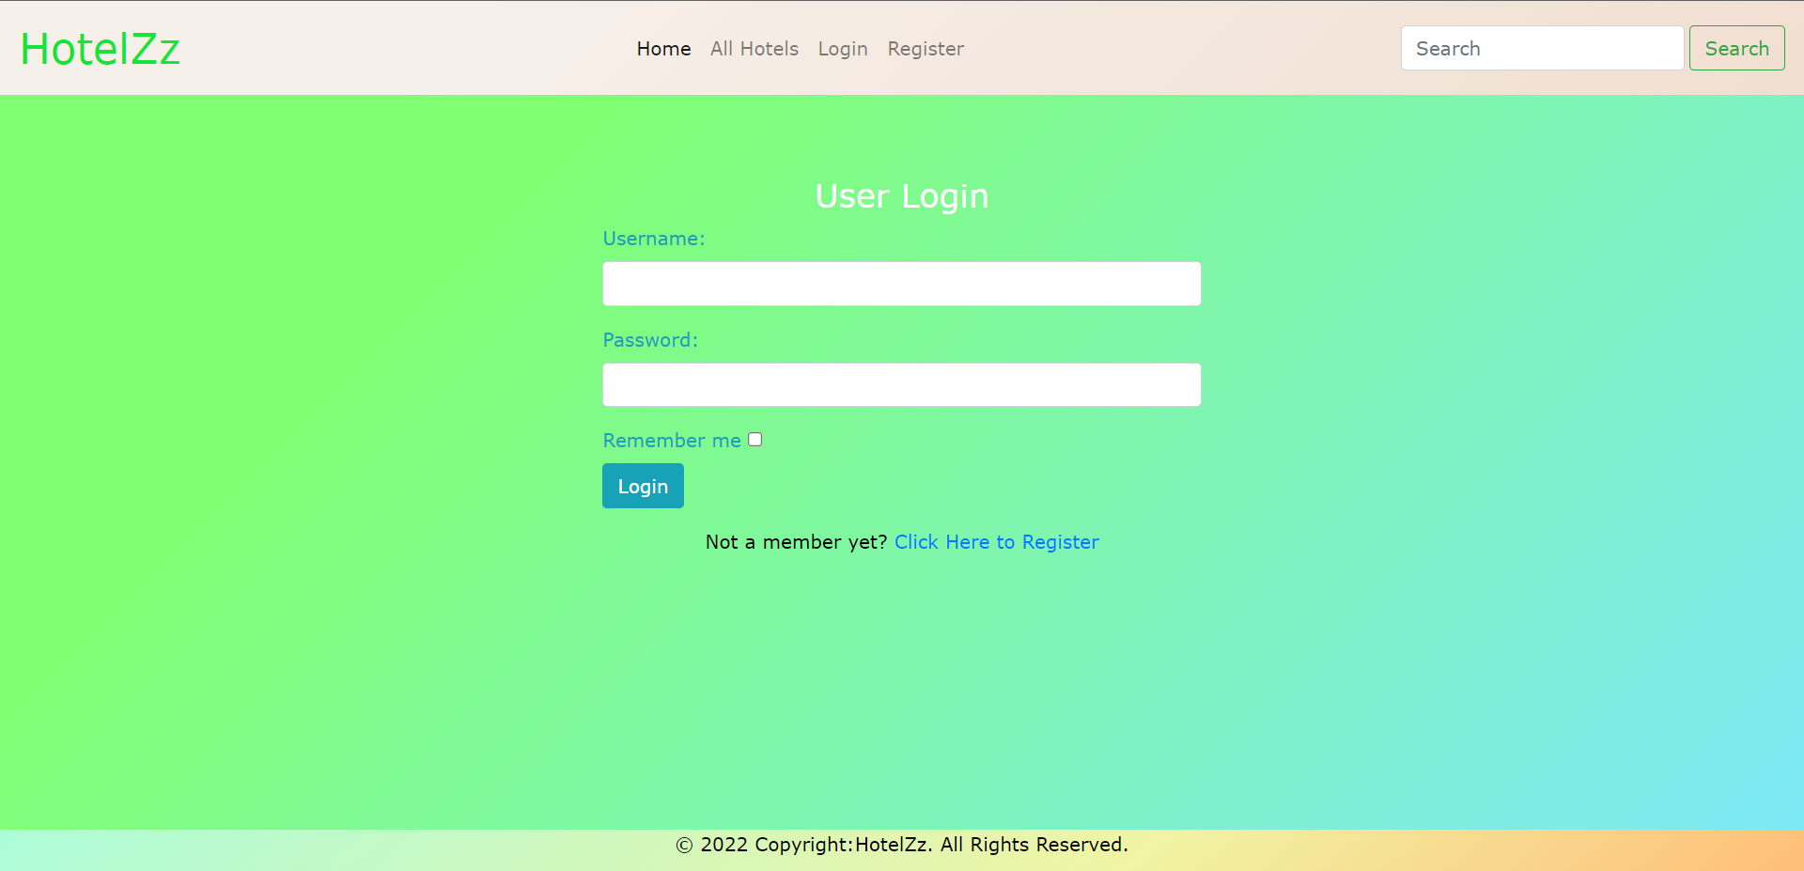

Figure HotelZz Log_in Page

#### Description:

Here are the login page of the our web application HotelZz.

### Screenshot of register page

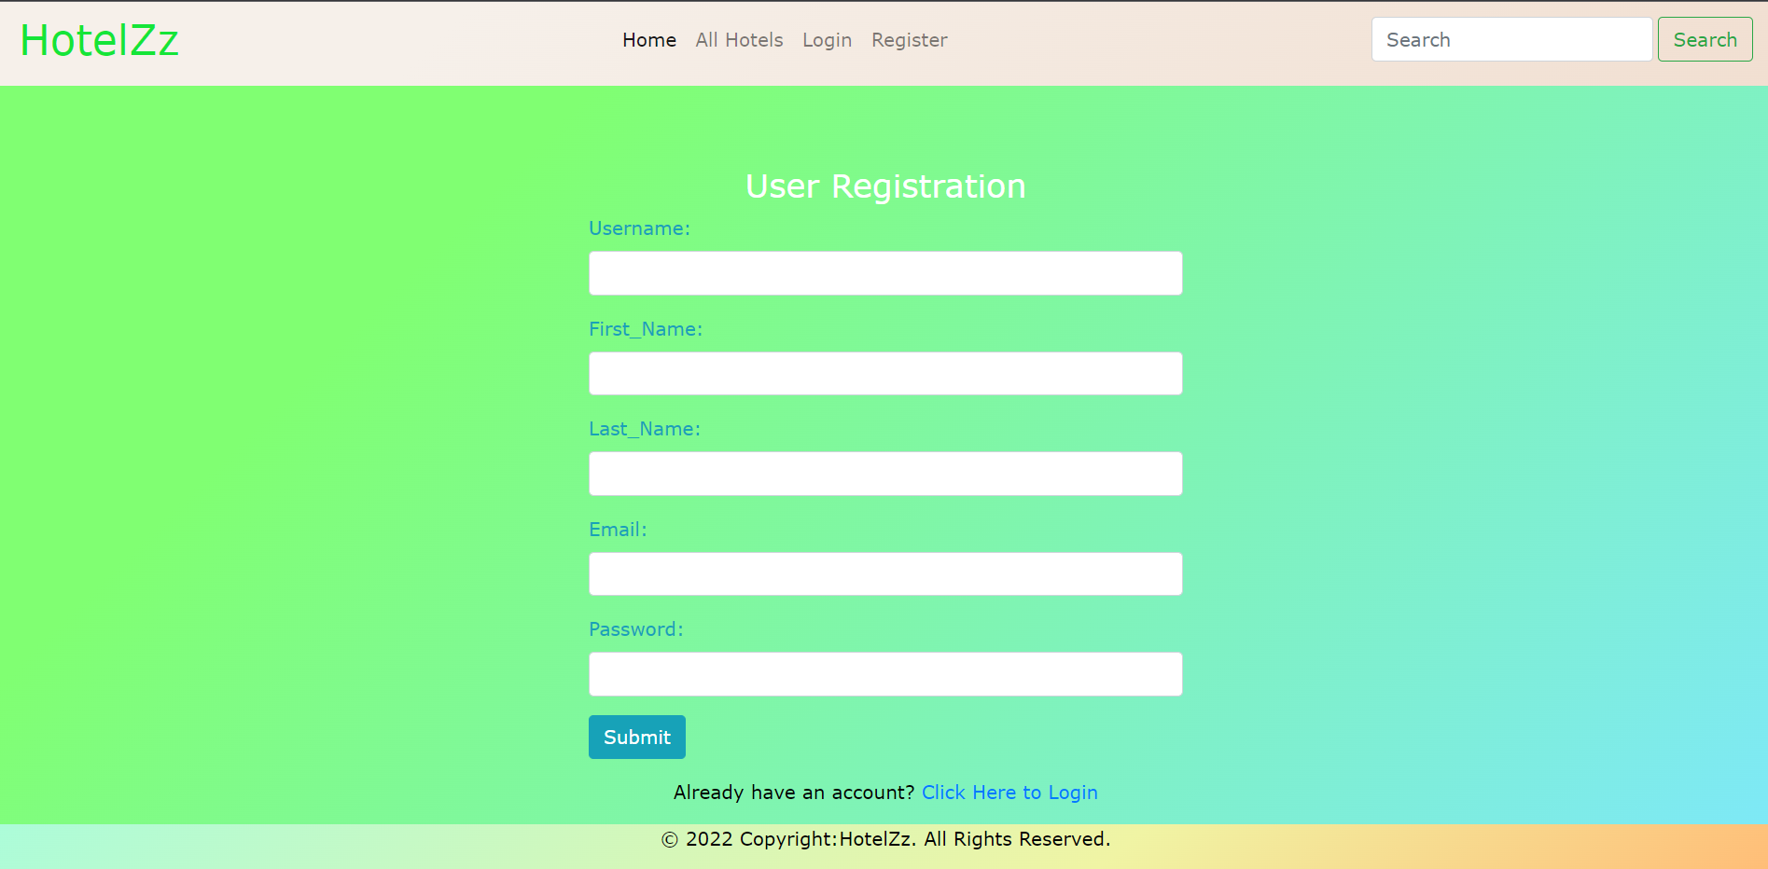

### Screenshot of All hotels by the location page

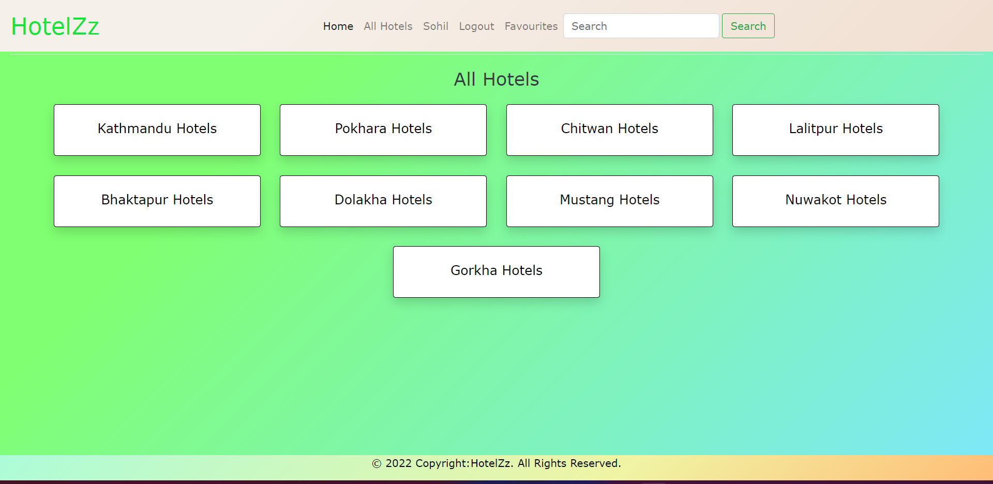

### Screenshot of favorite page

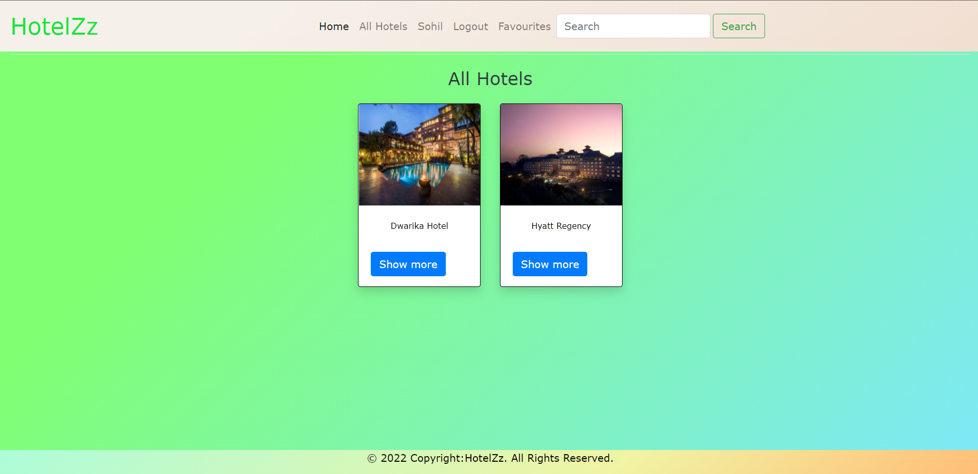

### Screenshot of Info page

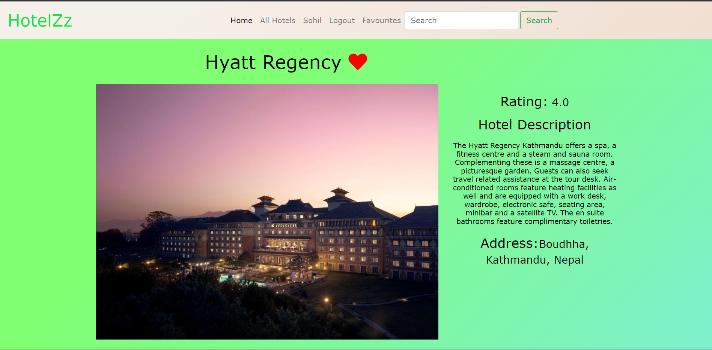

### Screenshot of comment box and user rating

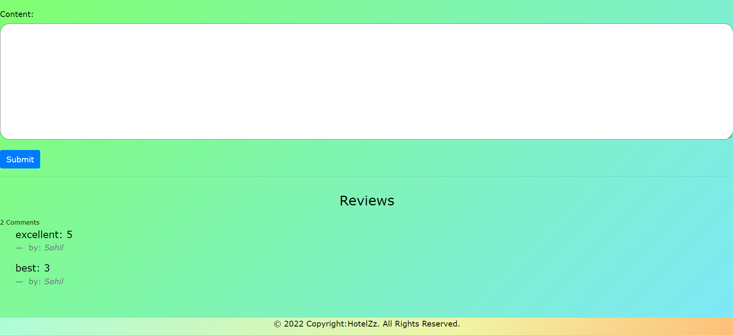

### Screenshot of email verification

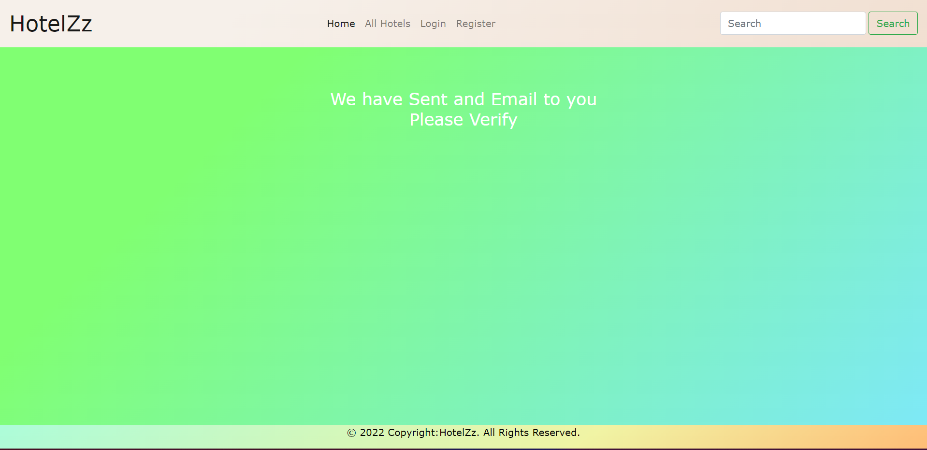

### Screenshot of email sent for verification

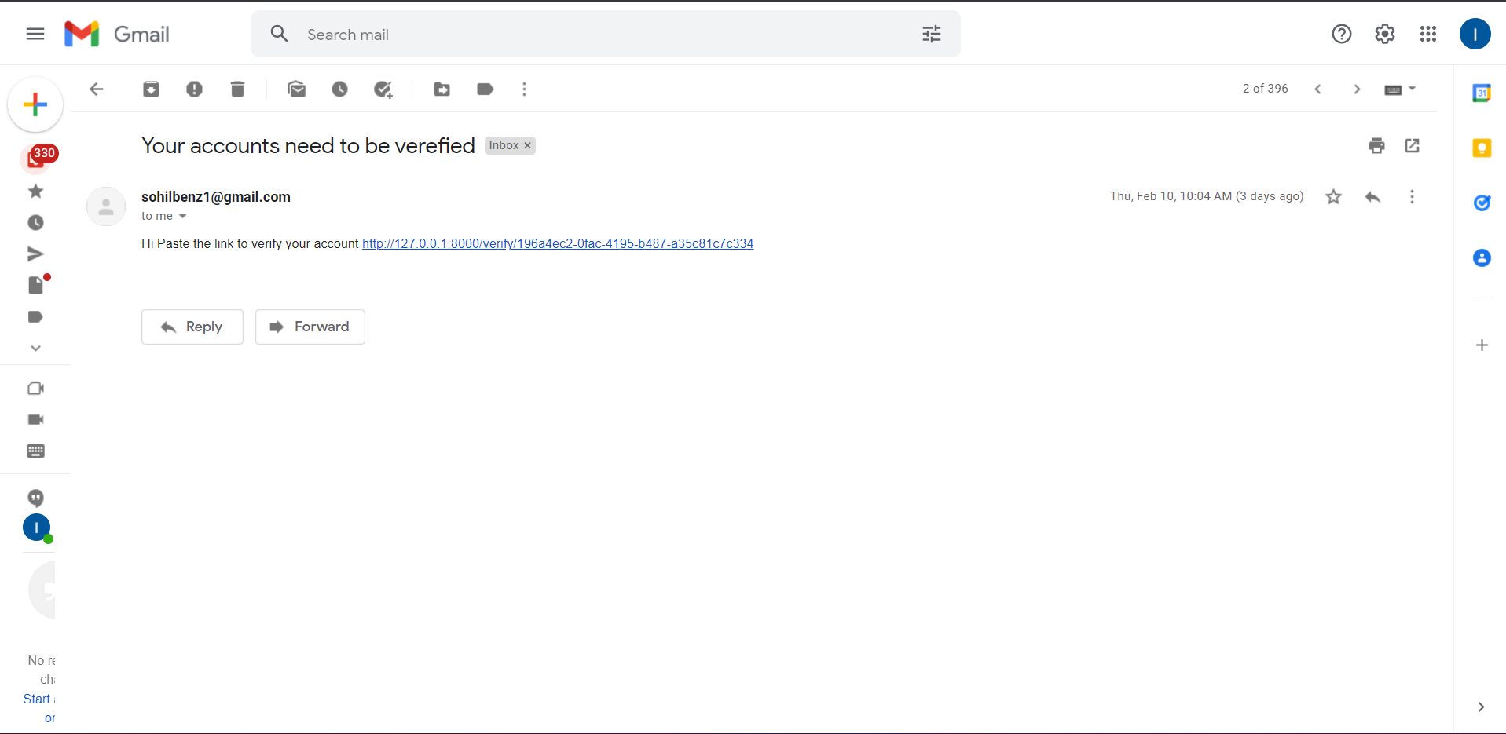

### Screenshot of verified user

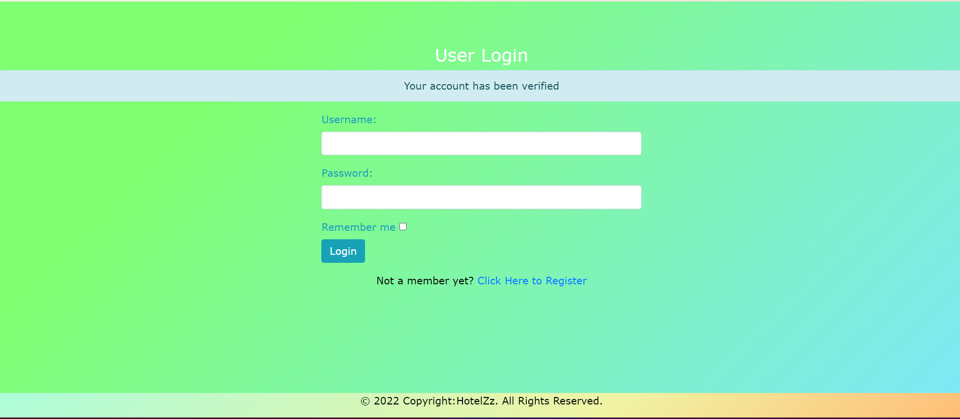

## Sample codes

# System Validation

# Conclusions and Reflections

## Critical evaluation

## Conclusion